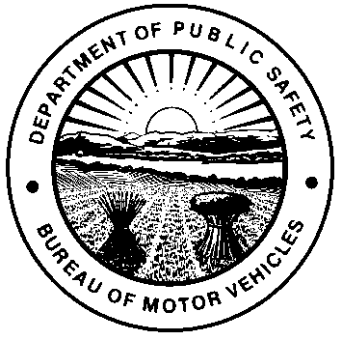 | OHIO DEPARTMENT OF PUBLIC SAFETY  BUREAU OF MOTOR VEHICLES  FIFTY HOUR AFFIDAVIT
PLEASE PRINT
NAME OF TEMPORARY PERMIT HOLDER |  |  |  | TEMPORARY INSTRUCTION PERMIT I.D. #
ADDRESS |  |  |  | CITY | STATE |  | ZIP CODE
NAME OF PARENT, GUARDIAN, OR CUSTODIAN |  |  | DRIVER LICENSE / I.D. CARD # |  | RELATIONSHIP TO TEMPORARY PERMIT HOLDER
ADDRESS |  |  |  | CITY | STATE |  | ZIP CODE
E-MAIL ADDRESS OR TELEPHONE #

The above named parent, guardian or custodian personally appeared before me, and has duly sworn that the above named temporary permit holder (under the age of 18) has completed fifty (50) hours of driving including a minimum of ten (10) hours of driving at night between one-half hour after sunset and one-half hour before sunrise.
SIGNATURE OF PARENT, GUARDIAN OR CUSTODIAN
X
Sworn to and subscribed in my presence this day of , 20 in County,
State of .
(Notary Seal)
Signature of Notary Public X My commission expires
NOTICE: Falsifying an affidavit is punishable by fine and / or imprisonment (R.C. Section 2921.21 and 4507.21[G]).
BMV 5791 4/16 [760-1073] |  | RESTRICTED

