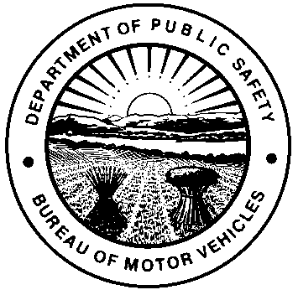 | OHIO DEPARTMENT OF PUBLIC SAFETY  OHIO BUREAU OF MOTOR VEHICLES  ELIGIBLE ADULT  IN LOCO PARENTIS AFFIDAVIT  (OHIO REVISED CODE [R.C.] SECTION 4507.05, 4507.21)
This form is to be used when the Temporary Instruction Permit Identification Card (TIPIC) holder is between 15 1/2 and 16 years old and is to be accompanied while driving by a responsible adult 21 years of age or older who acts in loco parentis (fulfilling parental responsibilities in the absence of a parent, guardian, or custodian).
I state under oath that all of the following are true:
- I am the parent (or guardian or custodian, if applicable) of a minor between the age of 15 1/2 and 16 years who is the holder of a temporary instruction permit.
- I understand that the minor must be accompanied while driving by a responsible adult 21 years of age or older who acts in loco parentis (fulfilling parental responsibilities in the absence of a parent, guardian, or custodian).
- I as parent (or guardian or custodian, if applicable) have cosigned for the minor to receive his or her temporary instruction permit.
There shall be no imputed liability to the co-signer under R.C. section 4507.07 if a minor under 18 years of age has proof of financial responsibility with respect to the operation of a motor vehicle owned by the minor, or if the minor is not the owner of a motor vehicle, with respect to the minor’s operation of any motor vehicle.
Proof of financial responsibility may be demonstrated by an insurance policy or bond, subject to the following liability limits:
- Twenty-five thousand dollars because of bodily injury to or death of one person in any one accident;
- Fifty thousand dollars because of bodily injury to or death of two or more persons in any one accident;
- Twenty-five thousand dollars because of injury to property of others in any one accident.
Pursuant to R.C. Section 4507.07 (C), a co-signer to a minor’s application for a license or permit may surrender the license or permit of the minor to the Bureau of Motor Vehicles and request that the license or permit be cancelled.
By signing this application, I understand the liability imputed to a co-signer of a minor’s application for a license pursuant to R.C. Section 4507.07. I hereby assume the obligation imposed by that section and understand that I may be held jointly and severally liable for the negligence or the willful and wanton misconduct of this minor applicant. I also understand that I may prevent any liability from being imputed to me if the minor maintains sufficient proof of financial responsibility. I am aware that I may surrender the license or permit of the minor to the Registrar of the Bureau of Motor Vehicles and ask that it be canceled at any time should I decide that I no longer wish to assume this obligation.
NAME OF ADULT

STREET ADDRESS

CITY |  |  | STATE |  | ZIP CODE
ADULT’S DATE OF BIRTH (MONTH, DAY, YEAR) |  | ADULT’S DRIVER LICENSE NUMBER |  | ADULT’S RELATIONSHIP TO THE MINOR
SIGNATURE OF PARENT (OR GUARDIAN OR CUSTODIAN)
X
Notary:
Sworn to and subscribed in my presence this day of , 20 in County,
State of .
(Notary Seal)
Signature of Notary Public X My commission expires

